15 Blue Lion Place 020 3714 4070

London Email: ers@electoral-reform.org.uk

SE1 4PU

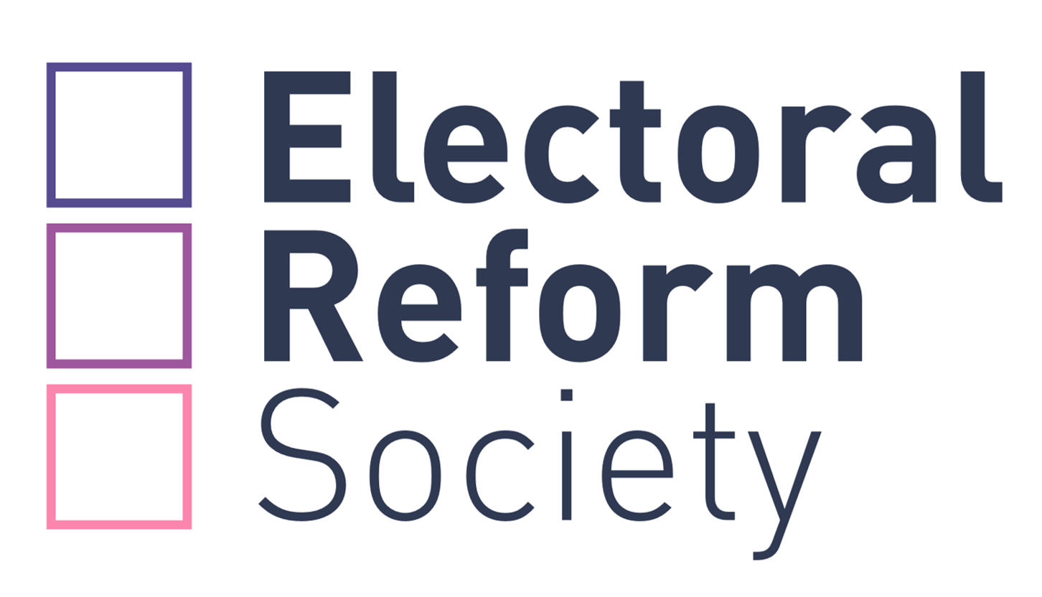

Thursday 19 November 2020

Dear Member,

**Annual General Meeting (AGM), Saturday 5th December 3.20pm**

## [www.mi-nomination.com/electoralreformsociety](http://www.mi-nomination.com/electoralreformsociety)

As you may know, given the extraordinary circumstances we find ourselves in this year, we are holding our 2020 Annual Members and Supporters Conference online as a virtual meeting on Saturday 5th September. The members-only AGM will also take place online this year, immediately following the members and supporters Annual Conference.

**It is therefore my pleasure to invite you to attend the Electoral Reform Society’s AGM to be held online on 5th December 2020 at 3.20pm (registration from 3pm).** Please use the link above to join the meeting.

I enclose full details of the AGM. As you will see, this year we have 3 resolutions from members to be debated and voted on. If you cannot attend or would prefer to cast your vote in advance of the meeting, you can send us a proxy vote by detaching and completing the enclosed form and returning it to:

**“Freepost Mi Voice”**

(that is all that is needed on the envelope).

**Please note that all proxy votes must be received by the deadline of Thursday 3rd December at 3.20pm.**

Thank you for your continued support and I look forward to seeing you on the 5th.

Yours sincerely,



Darren Hughes

Chief Executive

**AGM Agenda**

|  |  |
| --- | --- |
| **15.00** | **Registration** |
| **15.20**  **15.25**  **15.30**    **15.50**  **15.55** | **Annual General Meeting opens and welcome from the Chair**  **Minutes of the 2018 AGM, previous AGM on 30 November 2019 and Matters Arising**  **Receiving and adopting the Financial Statements for the year to 31 Dec 2019 (Andrew Copson, Treasurer and Jane Marshall from BHP Chartered Accountants in attendance)**  Copies of the Minutes of the 2019 AGM and the 2018 Financial Statements are available on our website or can be posted to members on request. If you require a hard copy by post please email [support@mi-voice.com](mailto:support@mi-voice.com) or phone 023 8076 3987.  **Appointment of Auditors**  The Council recommends that BHP Chartered Accountants be reappointed as the Society’s auditors for 2020-21  **Special Resolutions:**  **Special Resolution 1**  This requires a 75% majority to pass.  **Ordinary Resolutions:**  **Ordinary Resolution 1 Ordinary Resolution 2**  These Ordinary resolutions require a simple majority to pass. |
| **16.40** | **Results of Special Resolution 1 and Ordinary Resolutions 1 & 2** |
| **16.45** | **Close of meeting** |

**Resolutions for debate**

This year we have 3 resolutions that have been proposed by members.

In order to pass, a Special Resolution requires the support of at least 75% of votes cast by those entitled to vote, either in person or by appointment of proxy, at a general meeting, and is legally binding.

An Ordinary Resolution requires a simple majority (over 50%) of votes cast by those entitled to vote, either in person or by appointment of proxy, at a general meeting. The Ordinary Resolutions below are not legally binding but provide a useful indication of the views of members on the subject of the resolution for the Council to consider.

Please read the resolutions, supporting statements and Council recommendations using the links below before voting.

**Special Resolution 1: Prioritising the ERS’s main purpose**

This meeting resolves that, from now on and as its highest priority, the Electoral Reform Society shall work to achieve its primary object of having all elections of public bodies in the United Kingdom conducted by Proportional Representation through the Single Transferable Vote.

*Proposed by Anthony Tuffin  
Seconded by Lesley Abdela MBE*

**Statement by the Council AGAINST Special Resolution 1:**

**The majority of Council recommends VOTING AGAINST this motion.**

The objects of the Society are already clearly set out in its Articles. They are:

1. To secure the adoption of the principle of proportional representation by the method of the single transferable vote (preferential voting with quota counting) in elections in the British Isles and elsewhere for parliaments, provincial, regional and local authorities, other public and semi-public bodies and for officers and governing bodies corporate or unincorporate; and to facilitate development, improvement and mechanisation of the techniques associated therewith;
2. To advocate and support other measures, not being inconsistent with the above which are conducive to:
   1. strengthening democratic governance;
   2. maximising voter participation;
   3. ensuring that elections are conducted according to standards of fairness and equality, and that counting processes are transparent and open to scrutiny;
   4. ensuring that electoral processes are regulated so that no interest is able to secure an unfair advantage; and/or
   5. implementing internationally accepted standards of electoral practice; and
3. to advance the study of electoral science.

The Society’s current campaigning activities are entirely consistent with its objects. Pursuing the full list of objects is not only important from a good governance perspective, it also allows the Society to build links with allies and gives us a stronger media presence. All our campaigns strengthen the campaign for STV; none of our activities detract from it.

For example, the Society engaging in discussions on the size of the Welsh Assembly (Senedd) positioned ERS to directly advocate for the introduction of STV for that body. Introduction of STV is now one of three recommendations of the report of the Senedd committee on electoral reform (<https://business.senedd.wales/documents/s104463/Committee%20report%20-%20Summary%20of%20recommendations.pdf>). This massive campaign win would not have been possible without engaging with the committee on their topics of interest –notably the size of the Assembly.

The Society already feeds back to its members on a regular basis by email and via itswebsite and social media channels (except for those members who opt out of these communications or do not have an email address).

A similar motion was proposed by the same member to the 2019 AGM, requiring a 75% majority to pass, members voted as follows:

For -49.8%

Against –46.7%

Abstentions –3.4%

**For these reasons the majority of Council recommends voting against this motion**

**Statement IN FAVOUR of Special Resolution 1 by its proposer, Anthony Tuffin:**

Vote to advance the ERS’s main purpose!

This resolution should not be necessary and it is hard to understand why any member would vote against it or even abstain, but the Society now conducts many campaigns and, even if some of them are worthwhile, they can divert resources from its main purpose as set out in its constitution, www.electoral-reform.org.uk/who-we-are/governance-and-performance. There will be time for other issues after we have achieved our main purpose of Proportional Representation, which the UK needs so urgently.

I recognize that addressing wider problems in our politics may help us build support for PR, but the Society has been doing that for more than 20 years without getting us noticeably closer to our main aim. Also, we should not allow our main purpose to become hidden by other issues.

I am not asking the Society to abandon all other activities completely, but merely to make its own main purpose (the attainment of PR) its highest priority.

A similar, but more detailed, resolution last year received 161 votes for and 151 against, with 11 abstentions. Unfortunately, it failed to achieve the 75% needed to make it binding, so I hope there will be more support now for this shorter version, which leaves the details to Council and staff. If you think the Society already makes PR its highest priority, please still vote for this resolution to confirm that that is what you want, and to strengthen Council’s resolve to make PR the highest priority.

If you think the Society does not already make PR its highest priority but that it should do, then clearly you must vote for this resolution.

Every vote matters and we need 75% of them for this resolution to pass, so please vote now before you forget.

If you have any questions, please contact me at tuffin@waitrose.com(preferably) or 01243 604 715.

Thank you.

Anthony Tuffin (former Treasurer of the ERS)

Supported by: Lesley Abdela MBE (women's rights campaigner, international consultant on gender equality and democracy, and former Vice President of the ERS), David Brandwood, Colin Buchanan (retired Bishop and former President of the ERS), Kevin Chaffey (former ERS Council Member), Christopher Graham (ERS Council Member and Former UK Information Commissioner), David Green (ERS Council Member), Michael Meadowcroft (former ERS Chair and former Liberal MP), Ron Medlow (former Secretary of Labour Campaign for Electoral Reform and former ERS Council Member), Patrick Mills (former Committee Member of Suffolk Electoral Reform Group), John Strafford (Deputy Chairman of Conservative Action for Electoral Reform), Keith Underhill (former ERS Council Member), Anthony Webber, Brian Wichmann.

**Ordinary Resolution 1: Working for the ERS’s main purpose**

This meeting resolves that, from now on, the Electoral Reform Society should:

1. Work as its highest priority to achieve its primary object of having all elections of public bodies in the United Kingdom conducted by Proportional Representation through the Single Transferable Vote;
2. Establish and maintain pre-eminence of that object on the Society’s website; and
3. Report in writing annually to all members on action taken, and progress made, towards achieving that primary and longstanding object of the Electoral Reform Society.

*Proposed by Anthony Tuffin*

*Seconded by Philip Cole*

**Statement by the Council AGAINST Ordinary Resolution 1:**

**The majority of Council recommends VOTING AGAINST this motion.**

The objects of the Society are already clearly set out in its Articles. They are:

1. To secure the adoption of the principle of proportional representation by the method of the single transferable vote (preferential voting with quota counting) in elections in the British Isles and elsewhere for parliaments, provincial, regional and local authorities, other public and semi-public bodies and for officers and governing bodies corporate or unincorporate; and to facilitate development, improvement and mechanisation of the techniques associated therewith;
2. To advocate and support other measures, not being inconsistent with the above which are conducive to:
   1. strengthening democratic governance;
   2. maximising voter participation;
   3. ensuring that elections are conducted according to standards of fairness and equality, and that counting processes are transparent and open to scrutiny;
   4. ensuring that electoral processes are regulated so that no interest is able to secure an unfair advantage; and/or
   5. implementing internationally accepted standards of electoral practice; and
3. to advance the study of electoral science.

The Society’s current campaigning activities are entirely consistent with its objects. Pursuing the full list of objects is not only important from a good governance perspective, it also allows the Society to build links with allies and gives us a stronger media presence. All our campaigns strengthen the campaign for STV; none of our activities detract from it.

For example, the Society engaging in discussions on the size of the Welsh Assembly (Senedd) positioned ERS to directly advocate for the introduction of STV for that body. Introduction of STV is now one of three recommendations of the report of the Senedd committee on electoral reform (<https://business.senedd.wales/documents/s104463/Committee%20report%20-%20Summary%20of%20recommendations.pdf>). This massive campaign win would not have been possible without engaging with the committee on their topics of interest –notably the size of the Assembly.

The Society already feeds back to its members on a regular basis by email and via its website and social media channels (except for those members who opt out of these communications or do not have an email address).

A similar motion was proposed by the same member to the 2019 AGM, requiring a 75% majority to pass, members voted as follows:

For -49.8%

Against –46.7%

Abstentions –3.4%

**For these reasons the majority of Council recommends voting against this motion**

**Statement IN FAVOUR of Ordinary Resolution 1 by its proposer, Anthony Tuffin:**

This resolution merely asks the Society to give priority to its main aim, and suggests a couple of ways to do that.

I recognize that addressing wider problems in our politics may help us build support for PR, but that policy has not succeeded yet and we must not risk losing sight of our main purpose,

I am not asking the Society to abandon all other activities completely, but merely to make the attainment of PR its highest priority. That is the Society’s main purpose, [www.electoral-reform.org.uk/who-we-are/governance-and-performance](http://www.electoral-reform.org.uk/who-we-are/governance-and-performance).

A majority voted for a similar resolution last year. Unfortunately, it failed to achieve the 75% needed to make it binding, so Council did not even consider it. Although this resolution will not be binding, I expect Council to consider it if it is passed (i.e., if more than half the votes are for it) but, the bigger the majority, the more influence it may have on Council. So, please vote for it.

All the arguments for my separate Special Resolution also apply to this one. The Society should prioritise its main purpose over subsidiary activities. In addition, this resolution suggests the Society should make its main purpose very clear on its website and report regularly to members on what it has done and what progress it has made.

This resolution criticizes nobody. The only question for you to consider is not whether the resolution is necessary but whether you agree with it. If you agree with it, please vote for it.

Sadly, amendments to AGM resolutions are not possible so please vote for this resolution if you agree in principle with it, even if you would have liked to improve it.

Every vote matters, so please vote now before you forget.

If you have any questions, please contact me at [tuffin@waitrose.com](mailto:tuffin@waitrose.com) (preferably) or 01243 604 715.

Thank you.

Anthony Tuffin (former Treasurer of the ERS)

Supported by: Brian Wichmann, Anthony Webber, Keith Underhill (former ERS Council Member), John Strafford (Deputy Chairman of Conservative Action for Electoral Reform), Patrick Mills (former Committee Member of Suffolk Electoral Reform Group, Ron Medlow (former Secretary of Labour Campaign for Electoral Reform and former ERS Council Member), Michael Meadowcroft (former ERS Chair and former Liberal MP), David Green (ERS Council Member), Christopher Graham (ERS Council Member and Former UK Information Commissioner), Kevin Chaffey (former ERS Council Member), Colin Buchanan (retired Bishop and former President of the ERS), David Brandwood, Lesley Abdela MBE (women's rights campaigner, international consultant on gender equality and democracy, and former Vice President of the ERS).

**Ordinary Resolution 2: The Syddique Project**

This AGM urges Council to incorporate into the current strategic planning process a campaign for the introduction of the Single Transferable Vote for all local elections in England, such campaign to include:

1. The production of systems-specific campaign materials and a suite of web pages devoted to the campaign, with particular emphasis on the damage being done to local government by First-past-the-post and the benefits that STV would bring to local politics;
2. The creation and resourcing of local groups of ERS members in England;
3. The secondment of staff in the London Office to service and foster these new groups;
4. The allocation of an annual English Campaign budget sufficient to fund preparation of the campaign’s resources over 2021 and to launch the campaign in January 2022 ;
5. A detailed report of the English Campaign’s progress to the next Annual General Meeting of the Society.

This AGM further resolves that this campaign be named “The Syddique Project” in commemoration of the one-time ERS Chief Executive and long-standing reformer Eric Syddique who passed away earlier this year.

*Proposed by David Green*

*Seconded by Chris Graham*

**Statement by the Council AGAINST Ordinary Resolution 2:**

The majority of Council recommends VOTING AGAINST this motion.

We feel that the correct way to decide on campaigning messages is via a comprehensive strategy setting process with input from experts in the target sectors (i.e. political parties , trade unions, civil society groups and policy makers) and with specific polling and research to help target our resources correctly. The specific messages proposed in the supporting information, for example, are untested and may fail to convince those outside our existing supporter base.

The Council is currently undertaking a strategy review and is seeking ways to elicit useful input from members, alongside our ongoing calls to action to our members to sign petitions, complete surveys donate to specific projects etc.

Time has already been put into developing campaign resources for members to use which are available online at <https://www.electoral-reform.org.uk/take-action/resources/>. However, targeting resources at local groups rather than any members who wish to be more active, is likely to limit activity to urban centres and be heavily focused in London and the South, rather than the entire nation. National campaigning efforts also often result in activating members of various political parties to campaign on reform including at a local level.

Additionally, Council also does not support mandated secondment of central staff, all of whom have employment contracts for specific roles.

**For these reasons the majority of Council recommends voting against this motion**

**Statement IN FAVOUR of Ordinary Resolution 2 by its proposer, David Green:**

The Syddique Project endeavours to address two problems hampering our campaign:-

1, While the Single Transferable Vote may have been successfully introduced for local government elections in Northern Ireland and Scotland, with its eventual use now in prospect in Wales, no progress has been made in replacing the First-past-the-post voting system with STV for local elections in England, where 84% of the UK population resides.

2. The Society lacks an active local membership who could use the failings of the current voting system to promote the cause of reform in their own localities, surely a pre-requisite to creating a groundswell of support for reform for Westminster which was so sadly lacking in the run-up to the 2011 Referendum, with disastrous consequences.

The ERS has awesome resources which other pressure groups would give their eyeteeth for, and we need to devolve some of these assets to local communities. Moreover, as the COVID Emergency has demonstrated, you don’t need offices for action. What is needed are web pages putting the case against FPTP and for STV in videocasts, podcasts and text, campaign materials such as posters, badges, leaflets and stickers, and the development of local groups supported by the ERS staff at Blue Lion Place.

We propose that in 2021, groups be created in places where the ERS has concentrations of members so that the campaign can be launched in January 2022 to promote the issue of reform in selected localities such as in London, where the Borough elections are being held that year. One of this project’s features would be the flagging up of the failings of FPTP *in the run-up to Polling Day*, rather than wait until after the event, by which time interest has evaporated. Year by year, we would expand the number of local groups and thereby draw the attention of an increasing number of voters to the consequences of signing away their democratic rights with an X, so that it percolates through the nation’s conscience and builds support for reform. MPs will be more inclined to support voting reform for local councils than for Westminster, which will be the last domino to fall.

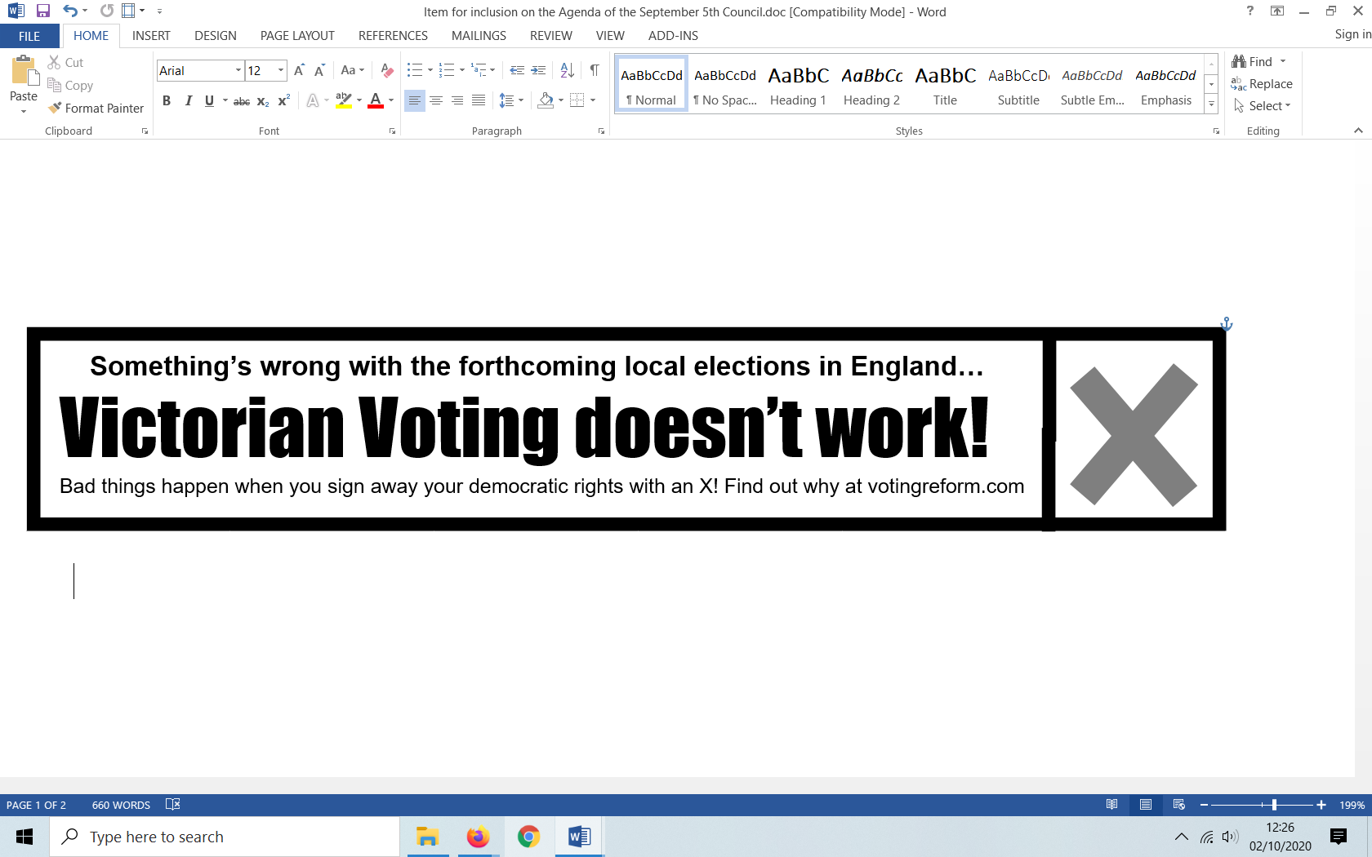

*Above: A new campaign and a new way of projecting the case for reform: X marks the rot!*

The Syddique project would also create an opportunity to refresh campaign terminology and narrative so that it is better suited for today’s media. Finally, the project would provide a regular drum beat for future timetabling so that, each year, the Society would prepare local activity in selected areas during January and February, followed by a national campaign in March and April; then, using Polling Day data, the Society would research, process and publicise disparities in the results during May and June, leaving the Autumn free for conferences, debate and preparation for the following year.

As members of Council, we look to Society members to back this project with a resounding majority to enable us to ensure that it is included in the strategy plan. It already has the support of David Brandwood, Colin Buchanan, Mike Burdett, Michael Meadowcroft, Patrick Mills, David Smith, Anthony Tuffin, Keith Underhill, Anthony Webber and Brian Wichmann. We hope it has yours.

David Green and Chris Graham

APPOINTMENT OF PROXY: 2020 RESOLUTIONS

Whether or not you are planning to attend the 2020 Annual General Meeting, you are invited to vote in the following ballot on the resolutions proposed.

**From:**

Name:

Address:

**I hereby appoint the Chair of the Meeting, unless another person is named below, as my proxy to attend and vote for me at the Annual General Meeting of the Society on 5 December 2020 and at any adjournment of that meeting.**

Signature:

Date:

If you do not want the Chair of the Meeting to act as your proxy, please give the name and address of your proxy, who must be a Society member in good standing, below **(do not enter your own name and address)**:

Name of proxy:

Address of proxy:

If no name is given above, it will be assumed that the Chair of the Meeting is your proxy.

# Voting instructions to your proxy:

You may instruct your proxy how to vote on the Resolutions by marking the appropriate box on the next page. **If your proxy is the Chair of the Meeting, your vote will ONLY be used where you have indicated you wish it to be used by checking the box.** You are therefore advised to complete the table on the next page as fully as possible.

**If your proxy is a member other than the Chair of the Meeting**, your vote will be used as indicated on the next page. Additionally, however, if you have not indicated how you wish your proxy to vote, your proxy will be free to vote, or to abstain, as he or she thinks fit.

**Resolutions**

|  |  |  |  |  |
| --- | --- | --- | --- | --- |
|  |  | **FOR** | **AGAINST** | **ABSTAIN** |
|  |  |  |  |  |
|  | **Special Resolution 1  (Prioritising the ERS’s main purpose)** |  |  |  |
|  |  |  |  |  |
|  | **Ordinary Resolution 1  (Working for the ERS’s main purpose)** |  |  |  |
|  | **Ordinary Resolution 2  (The Syddique Project)** |  |  |  |

**Return of this form:**

This completed form should be detached and posted to:

**“Freepost Mi Voice”**

(that is all that is needed on the envelope!)

to arrive **not later than 15.20 on Thursday 3rd December 2020.**

Proxy forms received after this time will not be accepted.

If you prefer, a version of this form is online and can be completed via our website.